Wang Chengting

20213204

ECON&DA

ECON3096 Project II. Data Analysis Replication

Compulsory Licensing: Evidence from the Trading with the Enemy Act

**Q1:**

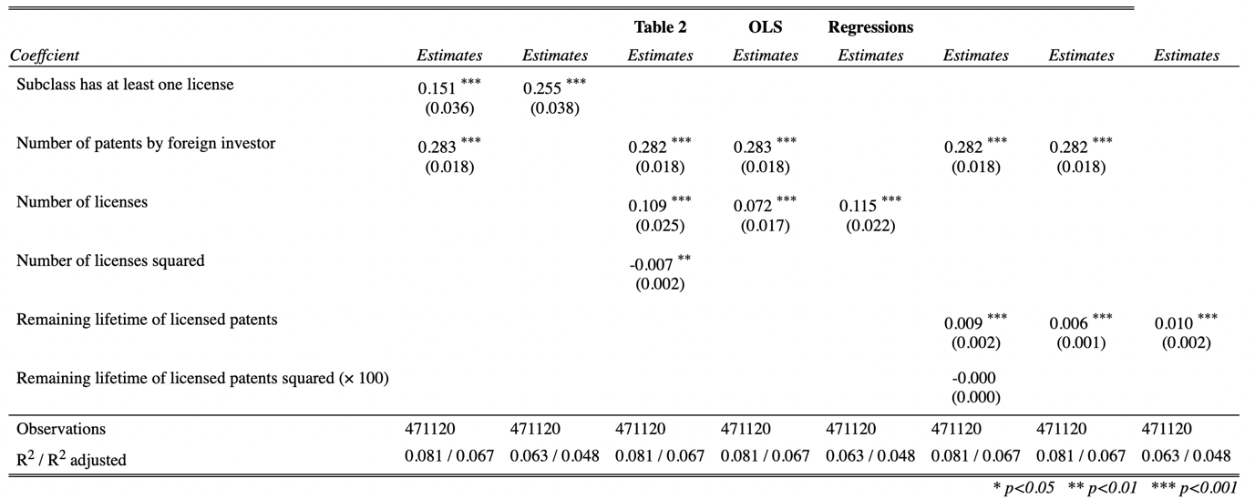

**Q2:**

As see above in model (1) and model (2), the coefficient of treat is significantly positive at 0.151 and 0.255, indicating that the policy compulsory licensing after 1919 encouraged more invention in USA. The result is consistent with the author’s hypothesis. Besides, the model (3)~(8) show the number of licenses, remaining lifetime of licensed, number of patents by foreign inventors could also affect number of patents by the US inventors at different levels.

**Q3:**

Parallel time trend assumption is that the difference in the treatment and control groups (bias) is constant over time. To confirm the assumption, we draw a line plot as follows:

As is shown above, these two lines seem parallel to each other pre-war (before 1918) in general.

**Q4:**

Consider parallel time trend assumption, we add “licensed class* grntyr” as a new variable “newvar” into former regression model (2), and we get the coefficient is 0.001, which is not significant, so we assume the parallel time trend.")

**Q5:**

Here we just replace the replace the dependent variable, and we get the table as follows:

By using the number of patents by Germany inventors, if only the “treat” involved in the regression i.e. model(2), it seems that the Act encouraged German invention, however, by adding “count_for” into model i.e. model(1), we see that the treat is not significant and even the sign of coefficient is negative, so we may infer that the Act does not encourage German invention. It is reasonable that the Act violate the interest of Germany.

**Q6:**

